**Vivekanand Education Society's Institute of Technology**



**Department of Computer Engineering**

**Group No.: 16**

**Date :- 02/08/2024**

**Project Synopsis (2024-25) - Sem V**

**MEDS - Bridging Surplus to Need, Reducing Waste**

Dr. Rohini Temkar

Assistant Professor , Department of Computer Engineering

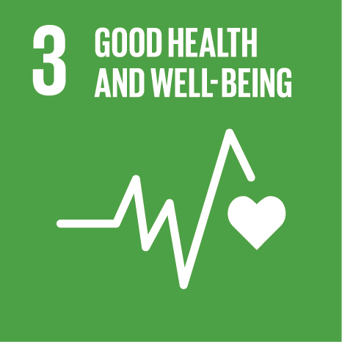

Sustainable Development Goals: Good Health and Well-Being

Hemant Satam Harsh Patil

[2022.hemant.satam@ves.ac.in](mailto:2022.hemant.satam@ves.ac.in) [2022.harsh.patil@ves.ac.in](mailto:2022.harsh.patil@ves.ac.in)

Suryanarayan Panigrahy Gaurav Gupta

[2022.suryanarayan.panigrahy@ves.ac.in](mailto:2022.suryanarayan.panigrahy@ves.ac.in) [2022.gaurav.gupta@ves.ac.in](mailto:2022.gaurav.gupta@ves.ac.in)

**Abstract**

This project introduces a mobile marketplace for leftover medicines, developed as a Flutter-based Android application operated by an NGO in collaboration with a trusted pharmacy and powered by machine learning. The goal is to reduce pharmaceutical waste and enhance medication accessibility by allowing users to donate or list unused medicines for sale. The backend is built with Flask and deployed on Render, ensuring a lightweight and scalable API service. Firebase Authentication handles secure user login and registration, while Firestore is used as the real-time NoSQL database to manage user data, medicine listings, and transaction history.

A Scikit-learn-based machine learning model is integrated to dynamically price medicines based on current supply and demand trends, promoting fair and efficient exchanges. The app provides a secure, user-friendly interface for seamless navigation and engagement. Evaluation metrics will include user engagement rates, transaction volume, reduction in medication waste, and improvements in access to affordable medicine. This initiative aims to create a sustainable, data-driven solution addressing both accessibility and pharmaceutical waste challenges.

**Introduction**

A marketplace for leftover medicines, operated by an NGO in association with a reputable pharmacy and enhanced by machine learning, offers an innovative solution to reduce waste and increase accessibility to essential medications. This system allows individuals to either sell or donate their leftover medicines based on current needs. The core of our platform relies on machine learning algorithms to evaluate optimal prices for both selling and donating, taking into account real-time demand and supply data. By using advanced technology, we ensure fair and efficient pricing, making medications affordable for those in need while promoting responsible resource use.

Initially, the idea of selling or donating leftover medicines might seem unconventional. However, with the advancement in technology and the growing awareness of sustainable practices, this approach is now gaining acceptance. The integration of machine learning marks a significant shift in how we manage and distribute medications, ensuring that valuable resources do not go to waste. The collaboration between the NGO and pharmacy guarantees the highest standards of safety and integrity.

**Problem Statement**

A significant amount of prescription medication is wasted due to side effects, early recovery, or excess purchase, leading to financial loss and environmental harm. Patients often discontinue medication because of adverse side effects or early recovery, leaving unused drugs. Over-purchasing also contributes to this waste. This represents a financial loss for individuals and healthcare systems and poses environmental risks due to improper disposal. Meanwhile, many people struggle to afford necessary medications, highlighting a need for better medication management and redistribution solutions to improve accessibility and reduce waste.

**Proposed Solution**

This project proposes the development of a Flutter-based Android mobile application that serves as a marketplace for leftover medicines, operated by a dedicated NGO in collaboration with a reputable pharmacy. The platform empowers individuals to either sell or donate surplus medications, aiming to reduce pharmaceutical waste and improve access to essential medicines for underserved communities.

Through the app, users can list their unused medicines for donation or sale, offering an affordable alternative for those who struggle with high prescription costs or providing a channel to contribute charitably. The initiative supports the safe and legal redistribution of medications, helping bridge the gap between surplus and shortage in healthcare access.

The backend is powered by Flask, deployed via Render for scalability and efficiency. Firebase Authentication ensures secure access, while Firestore handles real-time data storage, enabling smooth interactions, transaction history tracking, and user engagement. A Scikit-learn-driven machine learning model will assist in dynamically pricing medicines based on supply-demand trends to maintain fair and transparent transactions.

The app ensures safety and quality by working closely with a pharmacy partner, maintaining community trust and compliance with safety standards. This collaborative effort aims to build a sustainable healthcare ecosystem, reducing waste and promoting medication accessibility for those in need—all while contributing to a more equitable and environmentally responsible system.

**Methodology / Block Diagram:** 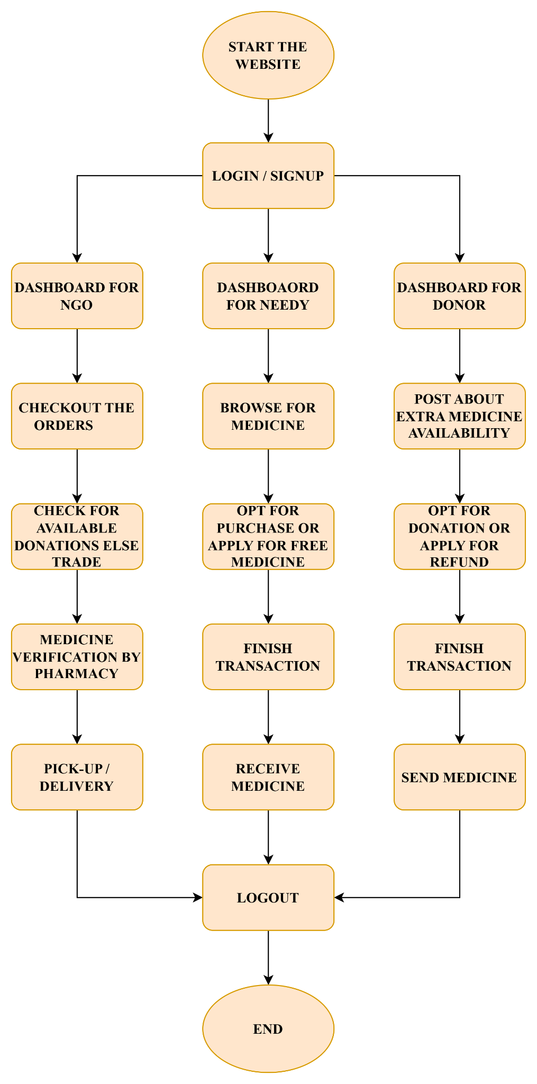

The methodology involves developing a Flutter-based Android application that acts as a marketplace for leftover medicines, operated by an NGO in collaboration with a reputable pharmacy. The app integrates modern technologies to ensure operational efficiency, safety, and scalability.

Users can list surplus medications through an intuitive mobile interface, choosing either to sell or donate them. A Scikit-learn-based machine learning model is integrated into the backend to analyze real-time supply and demand trends, enabling the system to dynamically price medications and recommend optimal matches between donors/sellers and potential recipients or buyers.

The backend is built with Flask and hosted on Render, ensuring a lightweight and flexible API layer. Firebase Authentication handles user registration and login securely, while Cloud Firestore serves as the primary database, offering real-time updates and scalability for storing user profiles, medication listings, transactions, and pricing data.

To ensure the safety and legality of transactions, the system incorporates strict verification processes, including prescription validation, expiry checks, and manual review in collaboration with the partnered pharmacy. This fosters trust and accountability within the user community and helps maintain compliance with medical and legal standards.

This multi-layered approach leverages mobile-first design, cloud infrastructure, and intelligent pricing algorithms to deliver a reliable, secure, and accessible platform that addresses both medication waste and affordability challenges in healthcare.

**Hardware , Software and tools Requirements**

### **Hardware Requirements**

* **Development Machine:** Computer with minimum 4GB RAM, 256GB SSD
* **Recommended:** 8GB RAM for smoother Flutter development and model training
* **Smartphone:** Android device (for testing the Flutter app) or emulator

### **Software and Tools**

#### **🔹 Frontend Technology**

* **Flutter** (for cross-platform mobile app development)
* **Dart** (programming language used with Flutter)

#### **🔹 Backend Technology**

* **Flask** (lightweight Python web framework for API development)
* **Render** (for deployment of Flask backend)

#### **🔹 Database Management**

* **Cloud Firestore** (NoSQL cloud database from Firebase for real-time data sync)
* **Firebase Authentication** (for secure login, registration, and user management)

#### **🔹 Machine Learning Libraries & Frameworks**

* **Scikit-learn** (for model building and predictive analytics)

**Proposed Evaluation Measures**

To ensure the success and effectiveness of the marketplace website for selling or donating leftover medicines, operated by an NGO in association with a reputable pharmacy, the following evaluation measures are proposed:

1. **User Participation and Engagement**: Track the number of users registering, listing medications, and making purchases or donations to gauge platform acceptance and usability.
2. **Transaction Volume**: Measure the frequency and volume of transactions and donations to assess marketplace activity and waste reduction.
3. **Cost Savings for Buyers**: Evaluate financial savings for buyers compared to traditional pharmacy prices to demonstrate affordability.
4. **Reduction in Medication Waste**: Quantify the amount of resold or donated medication instead of being discarded to directly measure waste reduction.
5. **User Satisfaction and Trust**: Collect feedback through surveys and reviews to gauge satisfaction with platform functionality, safety, and medication quality.
6. **Safety and Compliance**: Monitor medication quality verification and legal compliance processes to ensure safe and reliable transactions.
7. **Environmental and Community Impact**: Assess reductions in improper medication disposal and improved access for individuals struggling to afford medications.

**Conclusion**

The proposed Flutter-based mobile marketplace, operated by an NGO in collaboration with a reputable pharmacy, aims to address the pressing challenges of prescription medication waste and limited accessibility. By enabling users to donate or sell leftover medicines through a secure and user-friendly Android application, the platform seeks to reduce pharmaceutical waste and improve access to essential medications for underserved populations.Leveraging Scikit-learn-powered machine learning, the system ensures fair pricing and efficient medicine distribution based on real-time demand and supply patterns. Integration with Firebase and Firestore allows for secure authentication and real-time data management, while the Flask backend, deployed on Render, ensures seamless and scalable API services.

The platform’s effectiveness will be evaluated through key metrics such as reduction in medication waste, user cost savings, transaction volume, and adherence to safety and regulatory standards. Through this initiative, we aim to create a sustainable and equitable model for redistributing unused medications, balancing the disparity between surplus and scarcity, and fostering a responsible, community-driven approach to pharmaceutical resource management.

**References:**

[1]M. Debe, K. Salah, R. Jayaraman and J. Arshad, "Blockchain-Based Verifiable Tracking of Resellable Returned Drugs," in IEEE Access, vol. 8, pp. 205848-205862, 2020, doi: 10.1109/ACCESS.2020.3037363.keywords: {Drugs;Blockchain;Smart contracts;Supply chains; Biomedical imaging; Stakeholders;Servers;Blockchain;ethereum;healthcare;returned drugs;trustworthy tracking},

<https://ieeexplore.ieee.org/document/9256263>

[2]S. Shukla, Y. Kharde, G. N. Mandala, S. Bhikaji Jadhav and G. S. Doguparthy, "Optimization of Dynamic Pricing in E-Commerce Platform with Demand Side Management using Fuzzy Logic System," 2023 Second International Conference on Augmented Intelligence and Sustainable Systems (ICAISS), Trichy, India, 2023, pp. 848-853, doi: 10.1109/ICAISS58487.2023.10250726. keywords: {Fuzzy logic;Demand side management;Uncertainty;Decision making; Pricing;Linguistics;Market research;e-commerce;fuzzy logic system;customer traits},

<https://ieeexplore.ieee.org/document/10250726>

[3]An optimal system of recycling unwanted medicines by sustainable synergy of drugmakers, drugstores, customers and governments

<https://www.sciencedirect.com/science/article/abs/pii/S0959652622038768>

[4]N. A. Satrio et al., "Implementation Augmented Intelligence on Drug Inventory Management Forecasting," 2022 International Electronics Symposium (IES), Surabaya, Indonesia, 2022, pp. 564-569, doi: 10.1109/IES55876.2022.9888302. keywords: {Drugs; Hospitals; Predictive models;Inventory management; Augmented Intelligence;Database Monitoring;Inventory Management;Forecasting},

<https://ieeexplore.ieee.org/document/9888302>

[5]A. Mostofi and V. Jain, "Inventory Management and Control Of Deteriorating Pharmaceutical Products sing Industry 4.0," 2021 IEEE 8th International Conference on Industrial Engineering and Applications (ICIEA), Chengdu, China, 2021, pp. 394-400, doi:10.1109/ICIEA52957.2021.9436744. keywords: {Drugs;Analytical models;Computational modeling;Supply chains;Medical services;Quality control;Licenses;pharmaceutical supply chain;drug deterioration;cooperation;coordination;industry 4},

<https://ieeexplore.ieee.org/document/9436744?denied=>

**Mentor Signature:**

Dr. Rohini Temkar

**Group members Signature:**

Hemant Suryanarayan Gaurav Harsh

Satam Panigrahy Gupta Patil